**St macartan’s p.s homework policy**

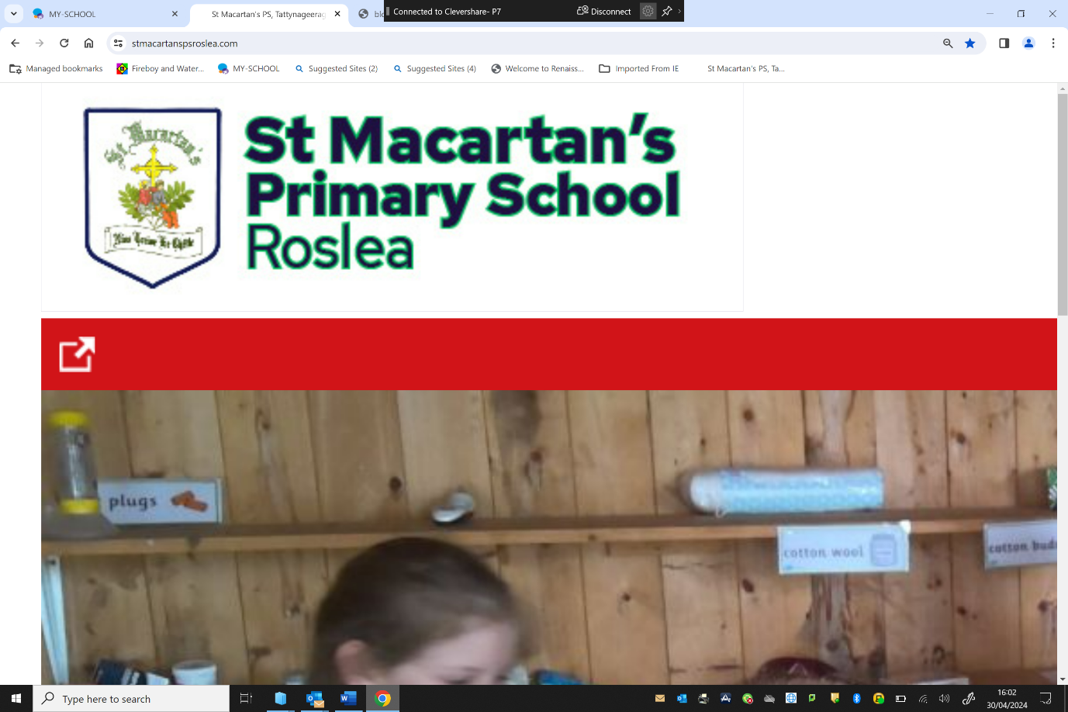

**AIMS OF POLICY**

* To provide a clear definition of the purpose and nature of homework at St Macartan’s Primary School.

• To identify our shared views of good practice.

• To establish how homework will be organised and how we ensure progression across the school.

• To identify the roles and responsibilities of those involved.

• To make clear the ways in which we aim to ensure that the policy makes an important contribution to the quality of teaching and learning in the school.

**DEFINITION**

At St Macartan’s Primary School we view homework as being an independent or parental supported task undertaken outside of curriculum time which reinforces, extends or enriches current learning.

**PURPOSE**

The purpose of homework at St Macartan’s Primary School is to provide opportunities for parents to be involved in their child’s learning. It enables children to practise and consolidate skills and aims to broaden the context of learning and provide enrichment and extension. Homework aims to enable children to take responsibility for their own learning, to become independent learners and to develop perseverance. Finally, it facilitates the development an effective partnership between teachers, parents and children.

Against this must be balanced each child’s need for recreation and the development of private interests and hobbies.

**CURRENT PRACTICE**

At the beginning of the academic year and regularly thereafter, each class teacher explains to pupils the requirements for homework in that class. Parents are also informed about expectations during parent teacher meetings.

**TYPE OF HOMEWORK AND THE TIME TO BE SPENT ON HOMEWORK**

|  |  |  |  |
| --- | --- | --- | --- |
| **Class** | **Time spent** | **Days** | **Areas covered** |
| P1 | Not more than 30minutes per night | 4 | Speaking and listening activities.  Reading.  Spelling and word investigations.  Book reviews.  Reading comprehension.  Independent research.  Practical maths investigations.  Collecting items linked to the theme.  Skills practice across a range of areas.  Data collection.  Educational games. |
| P2 | 4 |
| P3 | 4 |
| P4 | 4 |
| P5 | Not more than 45 minutes per night | 4 |
| P6 | 4 |
| P7 | Not more than 1 hour per night | 4 |
| **\*\*\* The importance of reading cannot be overemphasised. Parents are asked to encourage children to read as widely and as often as possible. The local community libraries should be visited regularly.** | | | |

The above table is merely a guide for each class. Homework may vary to take account of Religious Education, seasonal work or project work. Homework should not cause undue stress to the child, family or the teacher. If parents/guardians have any concerns they should not hesitate to contact the school. Likewise, if an occurrence in the child’s home life is preventing homework being completed the school should be made aware of this as soon as possible.

**ROLE OF THE CLASS TEACHER**

• To provide an explanation of homework tasks to parents when necessary and give guidance on how they might assist their child.

• To set up regular homework in an easily followed routine.

• To ensure that homework is set consistently across classes.

• To ensure any homework is purposeful and links directly to the curriculum being taught.

• To reward and praise children who complete homework tasks to the best of their ability.

• To mark homework as soon as possible and in line with the school’s marking policy.



**ROLE OF THE PRINCIPAL AND THE GOVERNORS**

• To check compliance of the policy.

• To meet and talk with parents when appropriate.

• To discuss with staff how far the policy is being successfully implemented.

• To inform new parents to the school so that they are aware of the policy and what it entails.

**ROLE OF THE PARENTS/CARERS**

• To make it clear that they value homework and they support the school by explaining how it can help learning.

• To support the school by ensuring that his/her child completes the homework.

• To provide a suitable place for their child to carry out their homework i.e. at a table in a quiet space.

• To become actively involved and support their child with homework activities i.e. listening to reading and asking questions about the reading, checking that spellings and mental maths facts have been learned and checking written homework to ensure neatness and completion.

• To encourage and praise their child when they have completed their homework.

• To provide a written explanation to the class teacher if, for any reason, your child is unable to complete homework.

**ROLE OF THE CHILD**

• To ensure they have everything they need to complete homework each week.

• To make sure they understand the tasks that have been set.

• To complete homework with the same level of effort as would be expected in class.

• To hand the homework in on time.

• To take on board any feedback about homework.

While we support the role of parents/carers we still expect your child to complete their homework as independently as possible. As children move into Key Stage Two, they are expected to take increasing responsibility themselves for the completion of their homework.

**COMPLETION OF HOMEWORK**

• If your child is having particular difficulties do not supply the answers, rather make a note on the page and the teacher will deal with the problem.

• If for any reason your child is unable to complete their homework because of another commitment, missing book etc. please send a written explanation to the class teacher. In such circumstances the teacher will decide the appropriate course of action.

**RECORDING OF WEEKLY HOMEWORK**

The school uses a homework diary for all pupils from P3-P7 in which all pupils record tasks. Parents may use the diary (or Home-School Link Book in P1/P2) to alert teachers to the non-completion of tasks or the difficulty in completing tasks.

**QUERIES ABOUT HOMEWORK**

If your child has a problem completing the homework or you have any questions, please make an appointment to call in and see the class teacher or write a note in their homework diary. We will do all that we can to resolve the problem. Your support in the process is vital for children’s success in developing self-study skills as they move on up through the school.

**INCLUSION AND DIVERSITY**

Inclusion and diversity are key principles in our school as it is made up of pupils from different backgrounds and experiences, each who have a wide range of skills, abilities, and interests. All children have equal access and inclusive rights to the curriculum regardless of their gender, race, disability or ability. We plan work that is differentiated for the performance of all groups and individuals. While it is important for SEN pupils to do as much in common with other children, at times they will benefit from weekly homework activities being differentiated according to the child’s ability.

**MONITORING AND EVALUATION OF HOMEWORK POLICY**

In order to ensure that our Homework Policy directly contributes to the quality of teaching and learning the provision of homework will be regularly monitored. Samples of homework activities will be reviewed by the principal as part of the school’s self-evaluation process. In addition, the monitoring of homework samples will form part of the Literacy and Numeracy co-ordinators’ monitoring responsibilities. Parents will also be given opportunities to share their views with teachers at parent consultations and other occasions as appropriate.

**Policy agreed and ratified by Board of Governors on: _________________________**

**Signed by Chair of Board of Governors: ____________________________________**

**Date: _________________________**

**Advice for Parents – Learning at Home**

**L.I.G.H.T.**

**Learning is Good at Home Together Do’s and Don’ts to make L.I.G.H.T. work**



**Do** – give lots of encouragement, praise and ensure your child gives of their best.

**Do** – show interest and talk with your child about their learning

**Do** – share stories, poems and books together

**Do** – jointly decide where and when homework should be done

**Do** – relax and enjoy this quality time of sharing the learning

**Don’t** – show anxiety or impatience

**Don’t** – do the work yourself. Leave ownership with your child

**Don’t** – hesitate to ask teacher for help

**Don’t** – pressurise your child or overdo the session.

**Remember – each child learns at his/her own pace and so you should never compare your child’s progress to another child. The class teacher uses their professional judgement to set suitable homework which will reinforce and build on your child’s learning.**