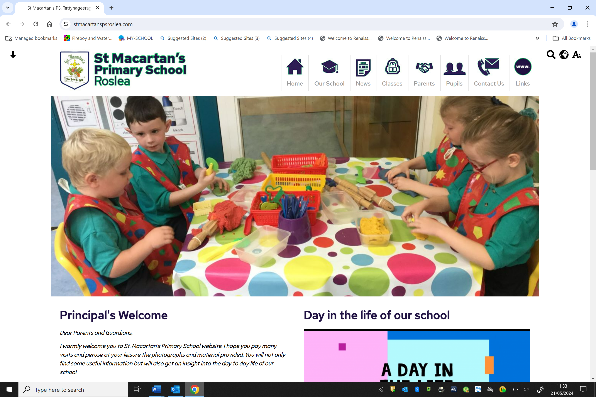
Principal: Mrs Caroline Rooney Tattynageeragh
Telephone: 02867751100 Roslea
Email address: Co. Fermanagh
info@stmacartans.enniskillen.ni.sch.uk BT92 7AW

___________________________________________________________________________

Dear Parent/ Guardian,

CONCUSSION AWARENESS

The Department of Education has issued revised guidance on concussion; Concussion guidance | Department of Education (education-ni.gov.uk).

Concussion is a brain injury which is usually caused by hitting the head or a fall. It can happen at any time, anywhere, for example during sports, in the school playground, or at home.

Concussion must always be taken seriously. It is vitally important that any child/young person suspected of having concussion should immediately be stopped from continuing whatever activity they are doing and be assessed by an appropriate healthcare professional within 24 hours.

A second injury when a child has concussion can be extremely serious and may even be fatal. It is vitally important therefore that medical clearance is sought before your child returns to school/play. Children should not resume physical activities such as physical education, sports, or games until permitted to do so by a medical professional.

Concussion may also affect your child‘s ability to learn at school for a period of time. As symptoms vary from child to child, a graduated return to school programme may be needed. If your child suffers a concussion in school or outside school, it is vitally important that you keep all people/organisations with responsibility for caring for your child informed so that they are aware of the potential dangers and any restrictions that may apply to the activities your child is permitted to do.

The ‘If in Doubt, Sit Them Out’ guidelines produced by The UK Government and the Sport and Recreation Alliance (supported by The Department for Communities and Sport Northern Ireland) is available on the Department of Education’s website www.education-ni.gov.uk and provides guidance on the signs to look out for.

Keeping everyone informed about concussion is in your child’s best interests. Parents/guardians have a key role in making sure that information is passed on to their child’s teacher, sports coach, youth leader or other care provider.

Yours sincerely,
Caroline Rooney

