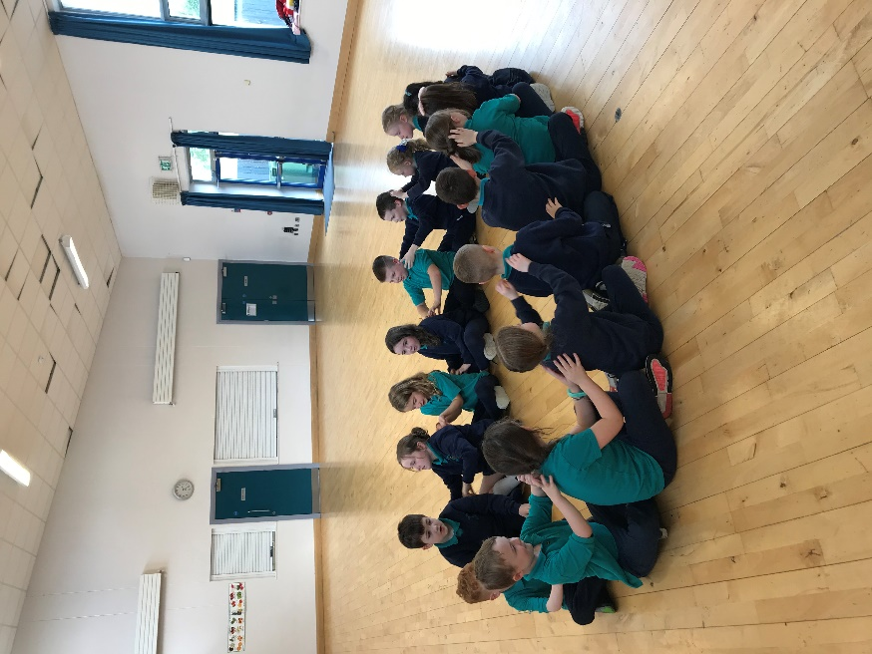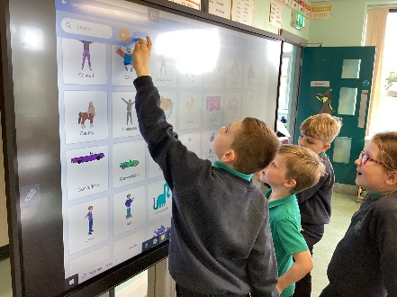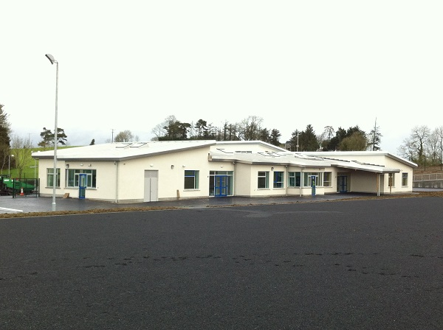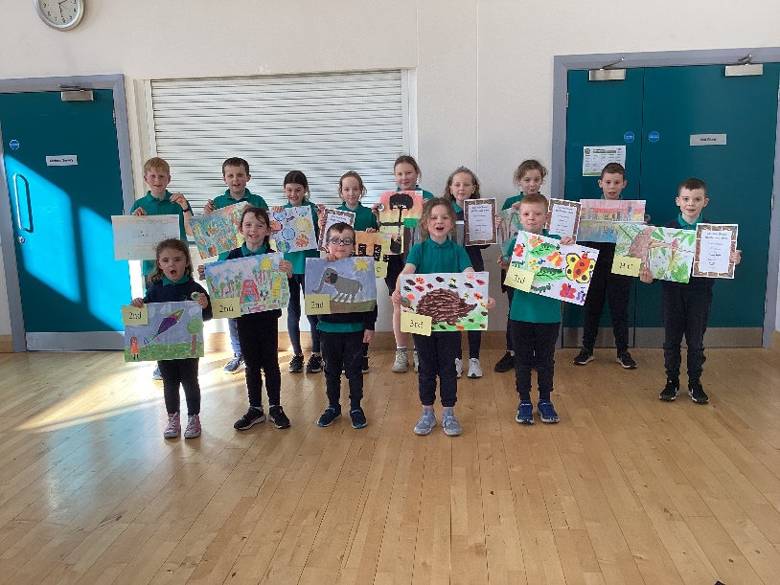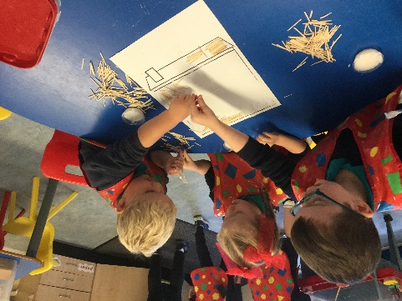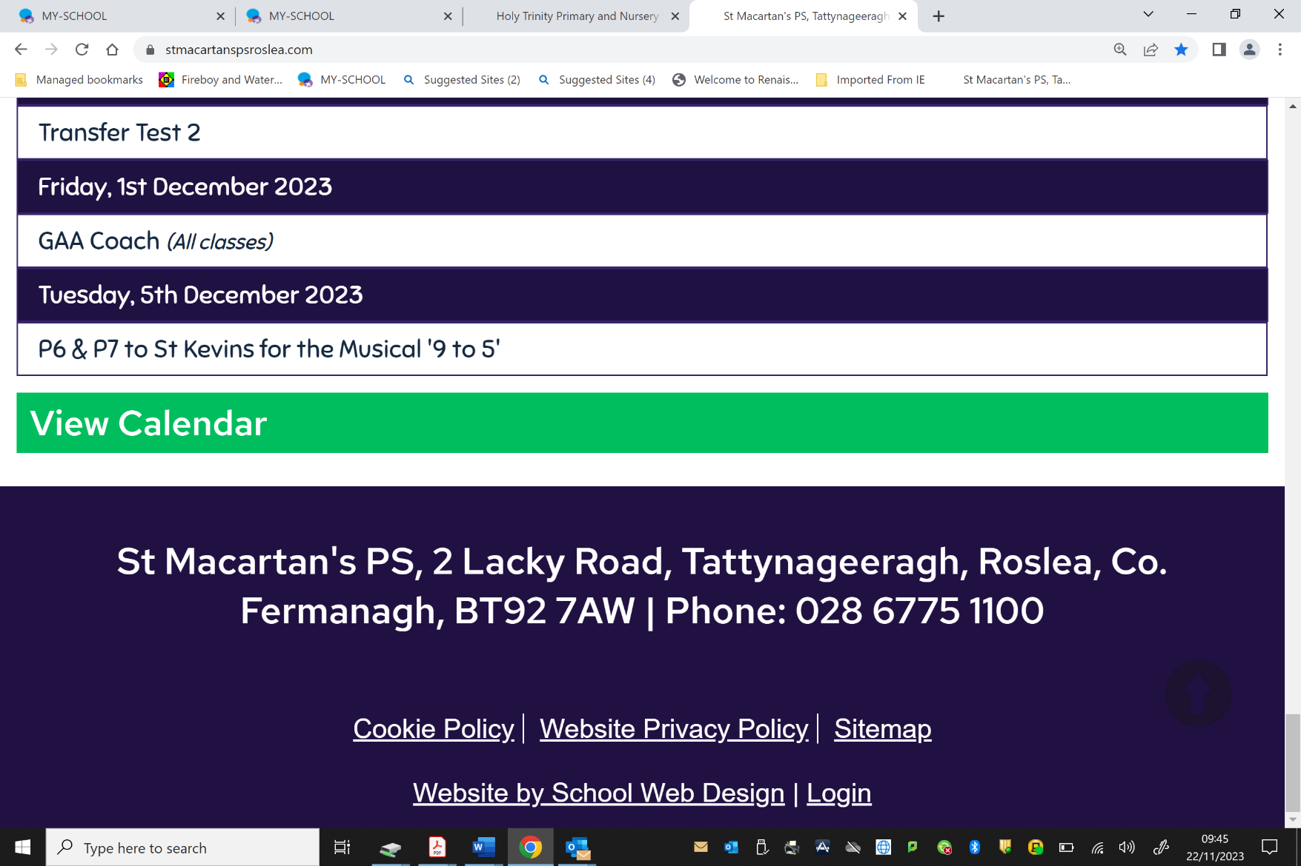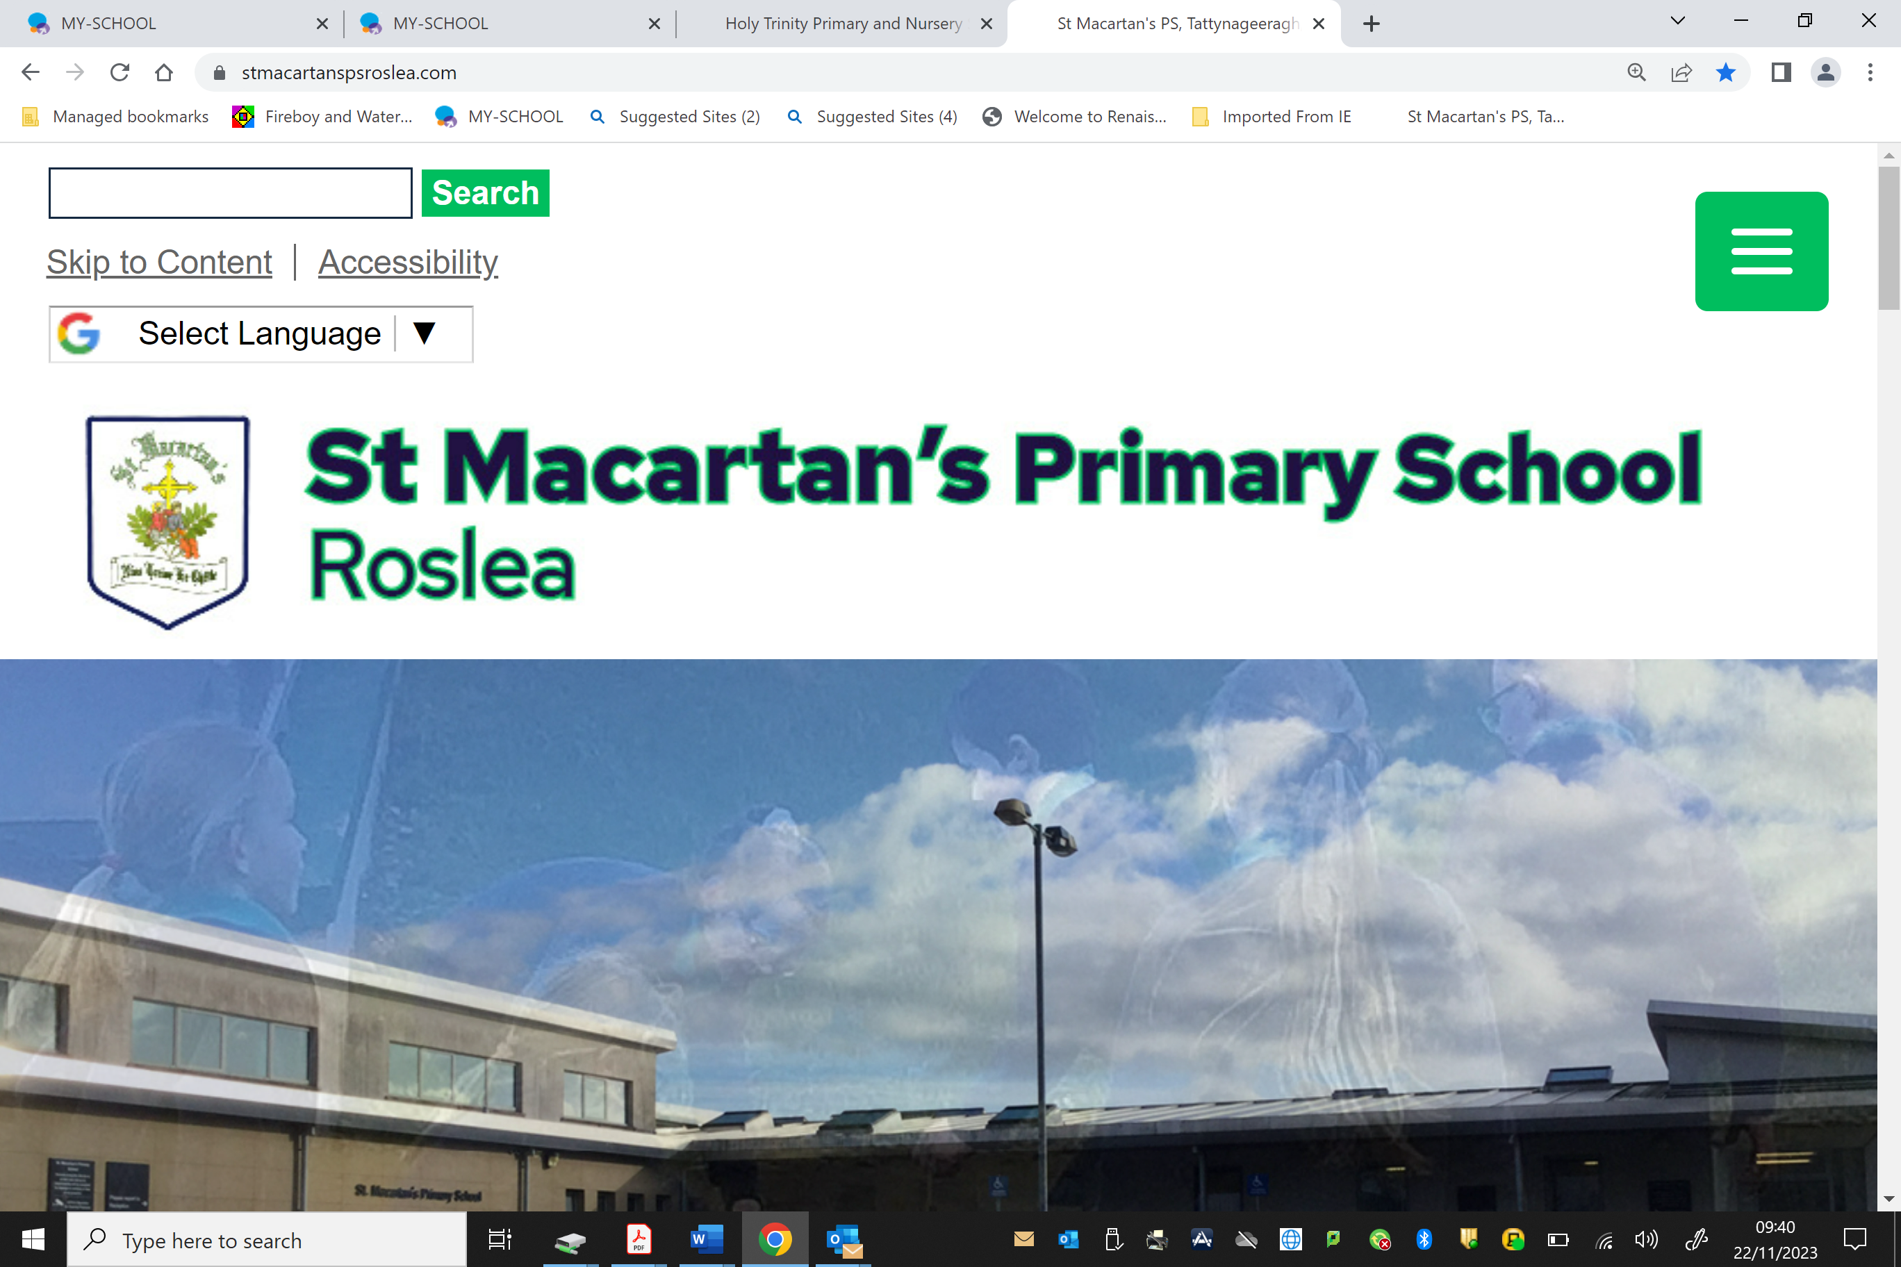

**Please feel free to contact the school if this date/time does not suit.**

**2025 P1 Admission**

**Is your child starting school in September 2025?**

**If so, then why not bring them along to our Open Morning to meet our staff and pupils and get an opportunity to experience our wonderful facility and gain an insight into our educational provision.**

**.**

**Tuesday 10th of December 2024**

**Tour of our school 9:30am – 10:30am**

**Refreshments will be served.**

**OPEN DAY 2025**

**For more information visit our school website:**

**www.stmacartanspsroslea.com**

* **Small class sizes and pupil/teacher ratio**
* **Modern and spacious facilities**
* **Dedicated and experienced staff with high standards for teaching and learning.**